Gilgit:

Baltit Fort

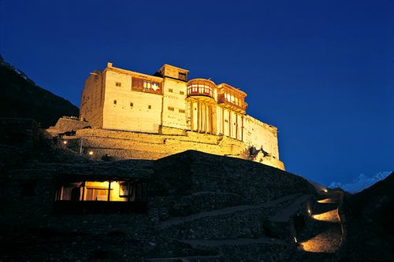

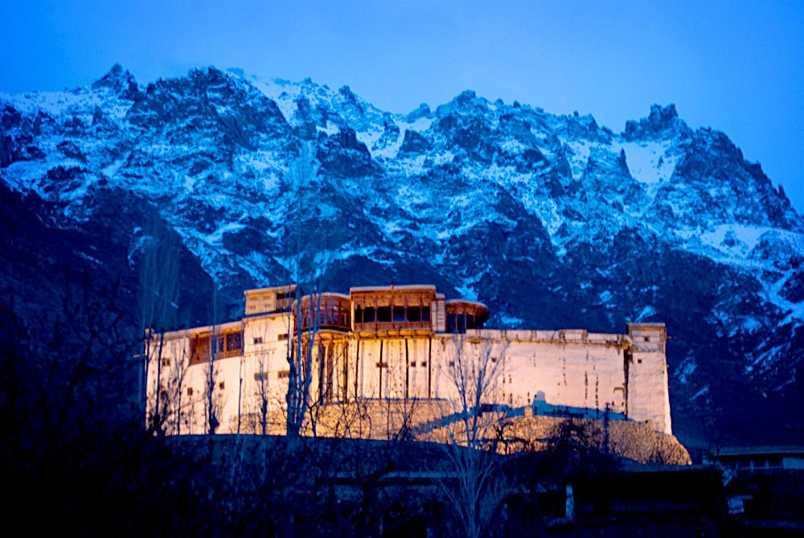

**Baltit Fort** is a fort in the Hunza valley, near the town of Karimabad, in the Gilgit-Baltistan region of northern Pakistan. Founded in the 8th CE, it has been on the UNESCO World Heritage Tentative list since 2004. In the past, the survival of the feudal regime of Hunza was ensured by the impressive fort, which overlooks Karimabad. The foundations of the fort date back to 700 years ago, with rebuilds and alterations over the centuries. In the 16th century the local prince married a princess from Baltistan who brought master Balti craftsmen to renovate the building as part of her dowry. The Mirs of Hunza abandoned the fort in 1945, and moved to a new palace down the hill. The fort started to decay which caused concern that it might possibly fall into ruin.